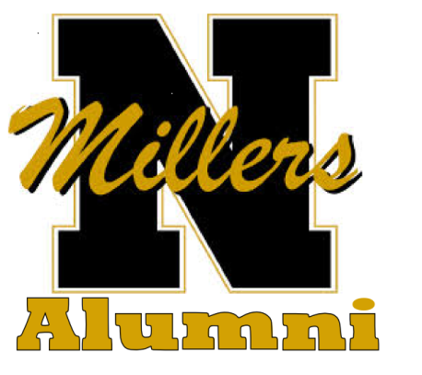

The N.H.S Alumni Association is an organization comprised of Noblesville High School graduates. It began in 1876 with the first graduating class. All graduates have been invited to join the organization. A volunteer 15 member Board of Directors oversees the annual activities of the group. There are over 2,000 members. Please consider joining today!

Membership Benefits:
The Association sends out a yearly newsletter to all members. Newsletters are mailed out in March of each year prior to our annual Alumni Banquet. We host the following 2 events each year:
- BANQUET- The annual banquet is held on the last Saturday of April at the high school cafeteria. At that time we honor the various classes such as the 50 year class. We have a social hour followed by a catered sit-down meal. We name our Alumnus of the Year and have a fun evening of fellowship and reminiscing.

- HOMECOMING- In the fall we participate in the Homecoming parade and have a reception after the Homecoming football game.

Scholarships
Each spring the Association awards scholarships to Noblesville High School graduates. All funds for scholarships are raised through donations. We offer a Gold Star Scholarship program – donors of $250.00 or more have their name engraved on a plaque which is displayed at our annual banquet in April.

Become a Member
There is a ONE-TIME membership fee of $20.00. There are two membership options. Lifetime membership for NHS graduates. Associate membership for those who would like to become a member but are not a NHS graduate.

You can follow the Noblesville High School Alumni Association at www.noblesvillealumni.org like us on Facebook at Noblesville Alumni or follow us on Twitter @MillerAlumni

Membership Application Name (full name including Maiden name) _______________________________________________________Class____________

Address____________________________________________City_____________________State________Zip_________

Phone_________________________________________Email____________________________________________________

Life Membership -$10.00_____ Life Associate Membership - $10.00 ______

Do you prefer your Alumni News via email_______________ or U.S. mail __________________

Mail Application to
Noblesville High School Alumni Association PO Box 818, Noblesville IN 46061

