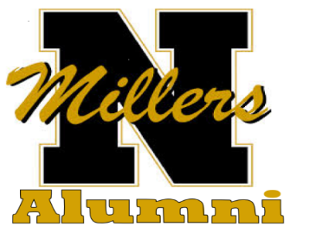
www.noblesvillealumni.org
Dear Friend of NHS,
We’d like to take this opportunity to both thank you for the outstanding support you or your business has given the Noblesville High School Alumni Association in the past, and to offer you an opportunity to continue that support.
The Alumni Association is comprised of Noblesville High School graduates and supports graduating seniors with more than $10,000 in scholarships and provides social activities for its members. Approximately 350 members attend the annual banquet at NHS.
Again this year we will begin selling ads for our annual newsletter that will be published in March of 2018. If you are not familiar with our newsletter, we annually mail a professional eight-page newsletter to our 1,700+ members. It features some historical news about NHS, a story on the scholarship winners from last year, information on the upcoming Annual Banquet and a special feature on the class that’s celebrating their 50th anniversary of graduating from the hallowed halls of NHS! For the last 60 years, the newsletter has been sent to its members via First-Class Mail in March. Our newsletter is also shared on our website and facebook page for additional exposure for you or your business
For our 2018 newsletter, we again, are going to include a page devoted to the local businesses, individuals, or groups who have been such great partners with the Association in the past and encourage their patronage. The best news is that an ad in our newsletter only costs $50.00.
DEADLINE TO PURCHASE YOUR AD IS JANUARY 15, 2018.
We hope that we can once again count on your support for the Association. All funds raised are used to publish and mail the newsletter and we will continue to give scholarships to deserving seniors.
Please reply by mailing your check for $50.00 for your ad to NHS ALUMNI, C/O Peggy Beaver, P.O. Box 818 Noblesville, IN 46061. Please let her know how you want to be identified in the ad. An invoice is also enclosed for adding your information. Make checks payable to NHS Alumni Association. You may also contact Peggy at 317-372-2674 with any questions you may have.
Finally, on behalf of the Alumni Association, we thank you so very much for supporting Noblesville High School!
Best regards,

NHS Alumni Board of Directors
(comprised of 15 community volunteers)

