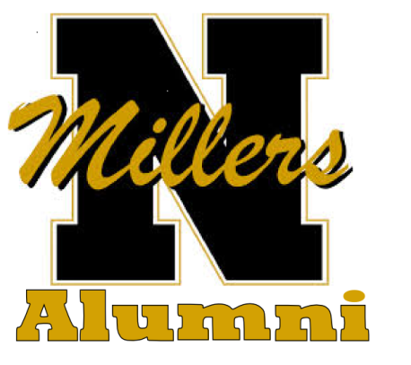
NHS ALUMNI ASSOCIATION
P.O. BOX 818
NOBLESVILLE, IN 46061

SPONSOR NAME ______________________________________

2018 NHS ALUMNI NEWSLETTER AD SPONSOR
INVOICE
NAME TO BE PLACED IN AD

TOTAL INVOICE $50.00
Make check payable to NHS Alumni Association and mail to the above address. Check due by January 15, 2018
Contact Peggy Beaver with questions at 317-372-2674

